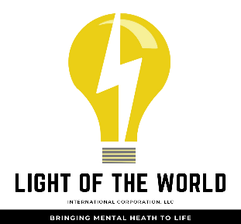

**Mental Health Resources**

Alabama Suicide Prevention and Resource Coalition (ASPARC)

P.O. Box 360244, Hoover, AL 35236

(205)-677-6116

Bradford Health Services

Residential Drug & Alcohol Rehab

Warrior Lodge

(205)-647-1945

Crisis Center:24/hour Hotline

3620 8th Ave S

Birmingham, AL 35222

(205)-323-7777

Crisis Text Line

Text BRAVE to 741-741

Emergency

911

JBS Mental Health Authority

940 Montclair Rd.  
Birmingham AL 35213

(205)-595-4555

Magic City Acceptance Center

3130 3rd Ave S

Birmingham, AL 35233

(205)-407-8157

Suicide Hotline

988

**Free or Limited Cost Counseling in Birmingham, AL**

Amelia Center (Grief Counseling Related to Children)

1513 4th Ave S, Birmingham, AL 35233

(205)-251-3430

Community Counseling

1150 10th Ave S, Birmingham, AL 35233

(205)-996-2414

Family Connection

2 Walker Run, Alabaster, AL 35007

(205)-663-6301

Family Violence Center

(205)-322-4878

Gateway Family Services

1401 20th St S, Birmingham, AL 35205

(205)-510-2600

Impact Family Counseling

1000 24th St S, Birmingham, AL 35205

(205)-916-0123

Light of the World: Bringing Mental Health to Life

7841 1st Avenue North, Birmingham, AL 35206

(256)-375-5641

Oasis Counseling for Women & Children

1900 14th Ave S, Birmingham, AL 35205

(205)-933-0338